Linux Community Hackathon
Linux OpenHack’26

Task 1:
Set up an Nginx server to serve the custom HTML page provided by the
Organizers.

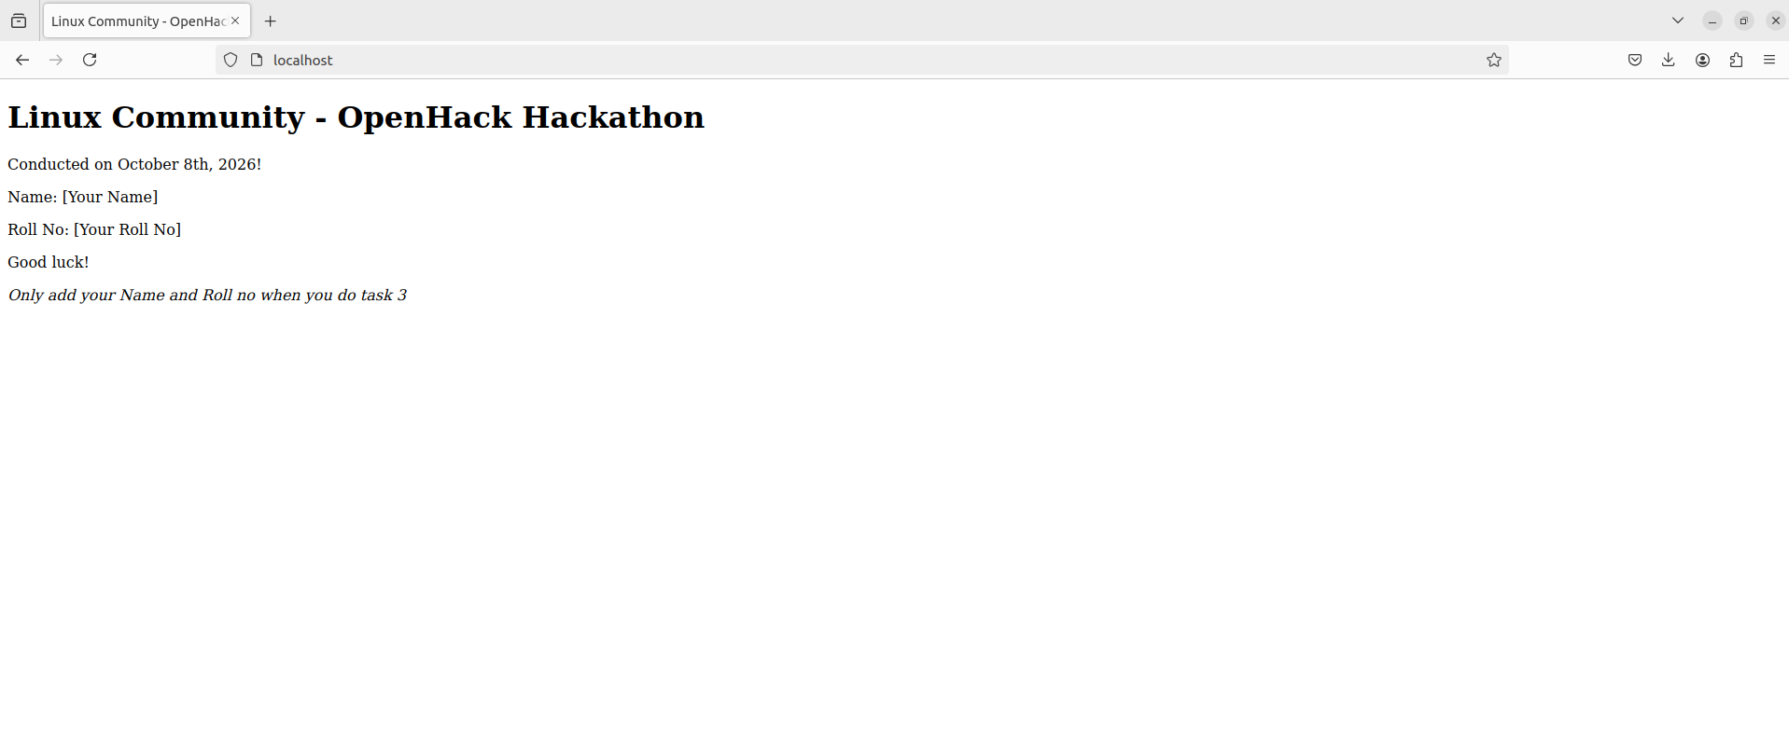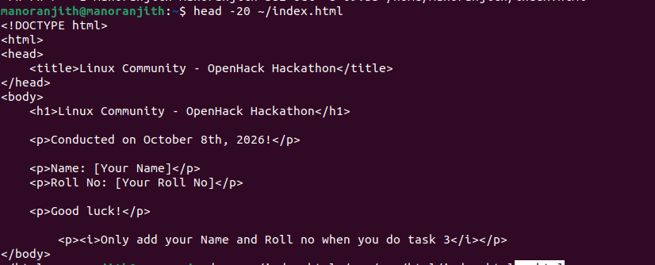

Task 2:
Access the hosted HTML page from another computer on the same network.
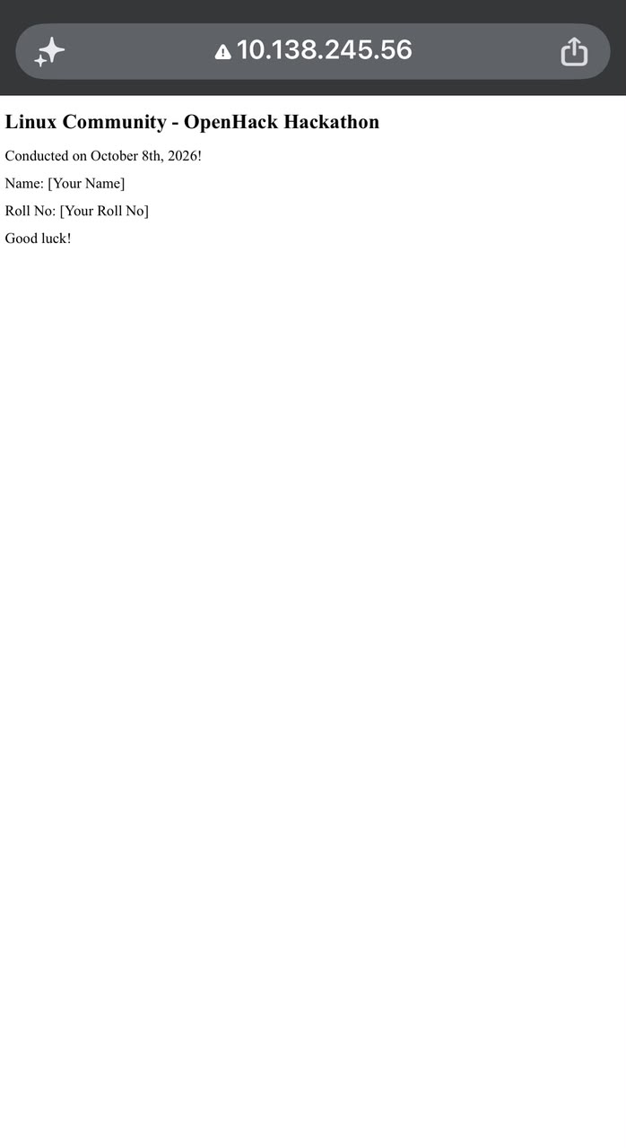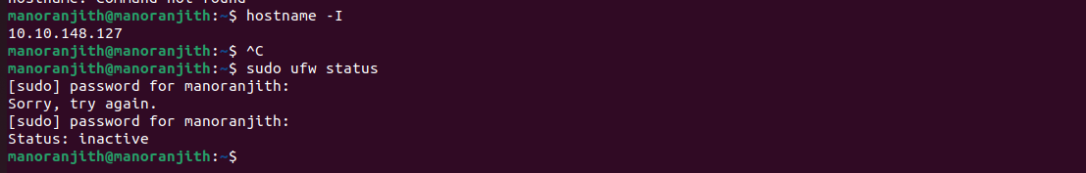

Task 3:
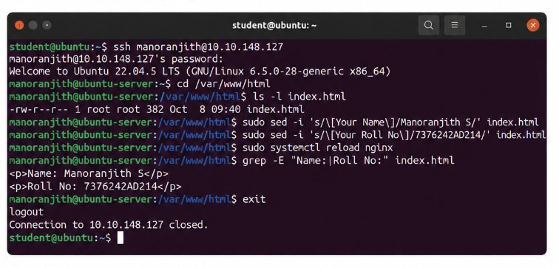
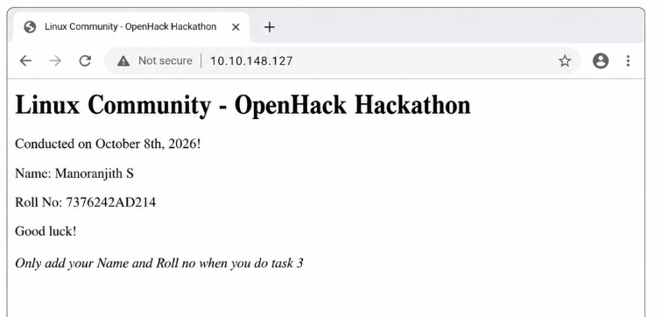

Task 4:Run a different HTML page on a separate port and verify that it can be accessed.

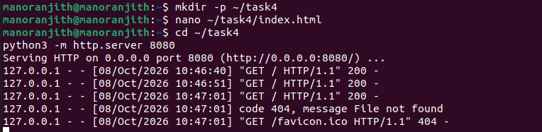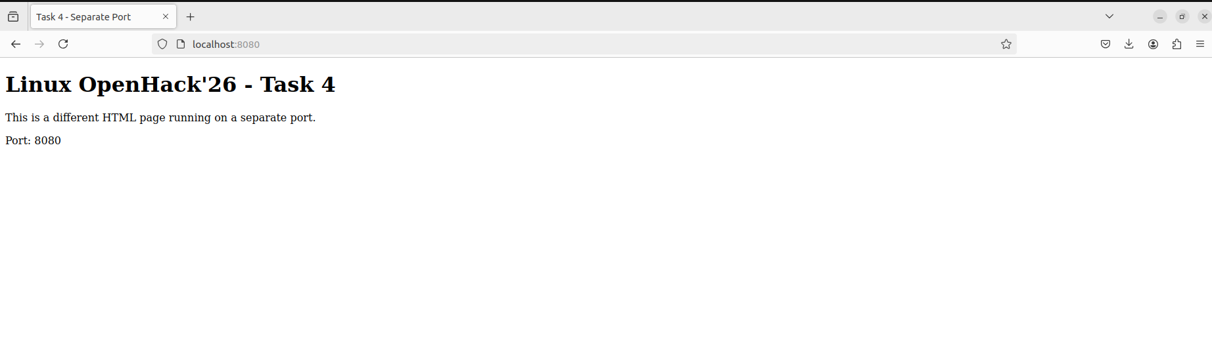

Task 5:Convert the hosted page into an HTTPS page and verify that it is accessible securely.
